Towards Virtual Human Twin Platform
Marian Bubak^{1,2}, Marek Kasztelnik², Maciej Malawski^{1,2}, Jan Meizner^{1,2},
Piotr Nowakowski^{1,2}, Piotr Połeć²
¹Sano Centre for Computational Medicine, Czarnowiejska 36, 30-054 Kraków, Poland
²ACC Cyfronet AGH, ul. Nawojki 11, 30-950 Kraków, Poland
{m.bubak,m.malawski,j.meizner,p.nowakowski}@sanoscience.org, {m.kasztelnik,p.polec}@cyfronet.pl
Keywords: HPC, medical simulations, personalized medicine, digital twin, Virtual Human twin
- Introduction
Health systems should enable personalized health promotion, disease prevention, diagnosis, and finally efficient treatment of patients [1] and health care providers should act accordingly to elaborated standards, in a conscious, empowered digitally, committed and responsible way. To realize this idea, we need good mathematical models of human physiology implemented in a form of computer simulation modules as well as availability of medical data.
- Description of the problem
Currently, the way to personalized medicine leads through elaboration of so called Virtual Human Twin (VHT) [2], which is a specific implementation of the idea of digital twin - a digital representation of a physical object, person, or process, placed in context in a digital version of its environment. VTH is an integrated, multi-scale, multi-temporal and multi-disciplinary representation of quantitative human physiology and pathology. To put the idea of VHT in practice, accordingly to the EU project EDITH [3], we require an inclusive ecosystem of digital twins in healthcare, implementation a federated cloud-based repository, gathering human digital twin resources such as models, data sets, algorithms, practices, and designing the architecture of a simulation platform to facilitate the transition towards personalized medicine.
- Related work
A series of research in this direction started by Peter Hunter with the Physiome Project [4] and was continued in the framework of the Virtual Physiological Human (VHP), sometimes equated with "in silico medicine", a field involving the use of individualized computer simulations based on physiology in aspects of prevention, diagnosis, prognostic assessment and treatment of disease and biomedical product development [5].
- Solution to the problem
We have analyzed internal structure and functional requirements of typical applications simulating human physiology gathered by partners of the EDITH project [3]. This formed a basis for elaboration of a demonstrator of the execution subsystem of the VHT ecosystem. It is a software system (Fig. 1) agnostic to the supported classes and formats of data items, easy to support a comprehensive data repository where various data items may be queried, retrieved, and fed into the computational models which constitute the simulation workflow, to run on classical HPC resources for scale-out studies which involve processing large amounts of data and “parameter study” types of computations. It enables model versioning: previous versions of the model are stored and may be referred to if needed, as well as reproducibility of computer simulations. The system also enables execution of computational models controlled by a set of scripts with a versioning system enabling collaborative editing and tagging specific versions that may be later selected to suit the researchers’ need. It provides a straightforward way to display, download and analyze simulation results. The functionality of the demonstrator was successfully validated with a set of typical VHT modules on the ACC Cyfronet HPC resources.

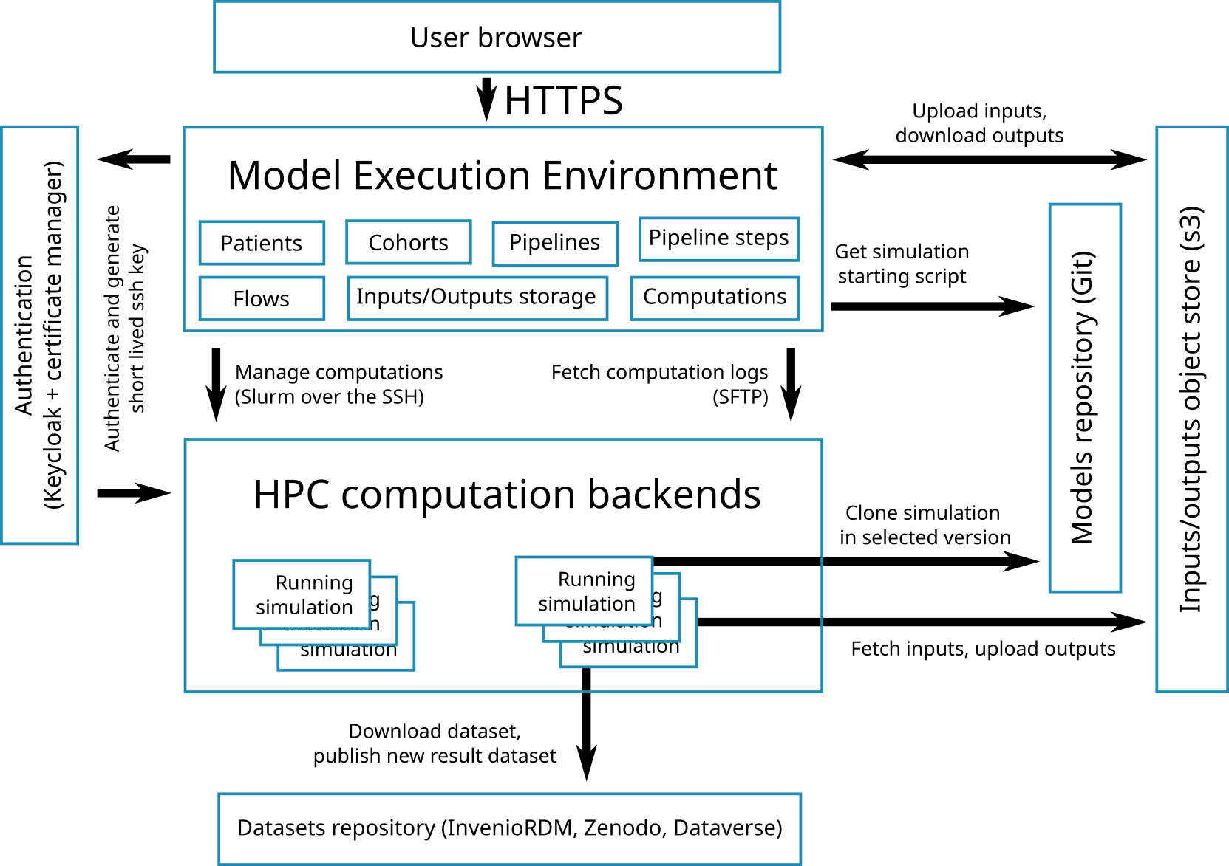

Fig.1. Architecture of the demonstrator of the VPH platform.

- Conclusions and future work
Our research has resulted in elaboration of an demonstrator which enables running on HPC resources modules of VHT and may be integrated with a repository of models and data. We consider it as the first step towards elaboration of the whole VHT ecosystem [3].
We started to demonstrate the value of VHT paradigm in the framework of the EU project GEMINI [6] and we expect that AI solution will considerably enhance VHT [7].
Acknowledgements. We acknowledge the support of EU under grants EDITH No 101083771 (Digital Europe), GEMINI No 101136438 (HORIZON), Meetween No 101135798 (HORIZON), and Teaming Sano No 857533, as well as ACK Cyfronet AGH for providing computer facilities and support within computational grant no. PLG/2023/016723.
References
- B Vicente, A. M., Ballensiefen, W. & Jönsson, J.-I. How personalised medicine will transform healthcare by 2030: the ICPerMed vision. J. Transl. Med. 18, 180 (2020), https://doi.org/10.1186/s12967-020-02316-w
- M. Viceconti, M. De Vos, S. Mellone, L Geris: Position paper from the digital twins in healthcare to the virtual human twin: a moon-shot project for digital health research, IEEE Journal of Biomedical and Health Informatics 28 (1), 491-501, 2024
- EDITH – European Virtual Digital Twin, EU Project, Digital Europe, https://www.edith-csa.eu/;
- Physiom Project - https://www.auckland.ac.nz/en/abi/our-research/research-groups-themes/physiome-project.html
- VPH Institute - https://www.vph-institute.org/
- GEMINI - A Generation of Multi-scale Digital Twins of Ischaemic and Haemorrhagic Stroke Patients, EU Project, HORIZON, https://dth-gemini.eu/
- Meetween - My Personal AI Mediator for Virtual MEETtings BetWEEN People, EU Project, HORIZON, https://www.meetween.eu/

